DATA ANALYSIS

Introduction
Conservationists are concerned about the invasion of exotic purple loosestrife in local wetlands. This plant is taking over the wetlands, and preventing native plants from growing. Efforts have been made in the city of Walpole to control the loosestrife using a biocontrol method: releasing Galerucella beetles. Land managers have been collected data (since they initiated treatments or beetle releases in 2000) to see if the beetles are helping to control the purple loosestrife. Beetles were released in early summers of 2000, 2001, and 2002 (10,000 beetles released each year). The site was monitored in the late summers of 2000, 2002, 2003 (some parts of the protocol), 2004, and 2005.

Site Description: Turners Pond is an approximately 18 acre pond located about one mile west of the center of Walpole. The pond is within the Mine Brook drainage, which connects to the Neponset River about a mile downstream of the pond’s outlet. The treatment area is a 1.7 acre impounded wetland located between the pond outlet and a railroad crossing. The site contains a permanently flooded segment of Mine Brook running down the center and fringe wetlands dominated by buttonbush, highbush blueberry, dogwoods, and purple loosestrife. The site does not contain significant stands of cattails.
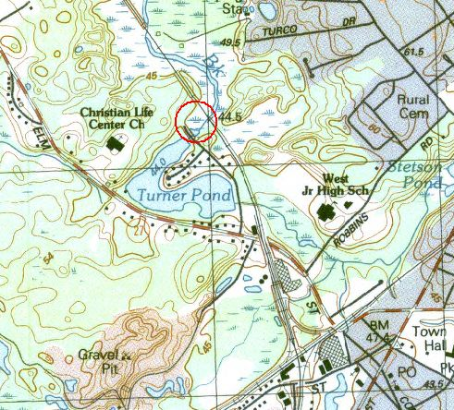
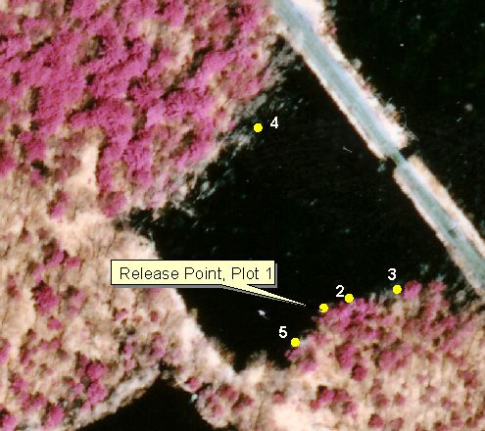
Site images: Topographic map showing site location (left) and aerial photograph showing site with monitoring and release plots identified (right).

Look at their data to see if this purple loosestrife control method has been effective at their site.

Name ________________________________________ Date ________________________
Data Analysis:
Looking at the data over time helps us to see if there are any trends. Are the purple loosestrife plants responding to the introduction of the beetles?
Hypothesis: Purple loosestrife will be reduced by the introduction of the Galerucella beetles.

Does the Walpole data support this hypothesis?
The data collected allows us to look at the changes to the purple loosestrife plants in more than one way. It is speculated that Galerucella beetles will reduce the height of the plants, reduce the amount of space that purple loosestrife is taking up (percent cover), and reduce the plants ability to reproduce by seed. We also expect to see an increased number of other plants growing alongside the purple loosestrife.
To analyze data, scientists take a number of samples, and then average them. The Walpole site has sampled 5 plots, and averaged them.
We expect that introducing beetles will Reduce Purple Loosestrife | Does the data from the site in Walpole support this hypothesis?
Reduced # stems
Reduce Percent (%) Cover (Amount of space purple loosestrife is taking up.)
Reduced Height
Reduce the amount of flowering and seeds produced by flowering.
Fill in the rest of the chart using the data from the excel spreadsheets.
 | Year | 2000 | 2002 | 2003 | 2004 | 2005 | 2006
1 | Average % COVER | 62.5 | 38.25 | 12.25
2 | Average # STEMS | 48.75 | 15 | 5.75
3 | Average Height |  |  | No data
4 | Average # inflorescences |  |  | No data
5 | Average # buds/5 cm inflorescences |  |  | No data
Create graphs (or use the ones provided) to show the change for each category.

Looking at your graphs, think about and answer the following questions in a paragraph.
- How quickly was the purple loosestrife altered? When was the most dramatic change?
- After how many years was purple loosestrife mostly eliminated?
- Do you think multiple year study/treatment is important? Explain your answer.
- How does reducing the number of buds and inflorescences help reduce purple loosestrife?
- Based on what happened in Walpole, would you recommend releasing beetles to control purple loosestrife in other locations? If yes, how many years would you recommend repeating the beetle release?
- Do you think the results are expected to be the same at other sites? Why or why not? What may lead to variability in site results?
 |  | Fall Monitoring Data - Turners Pond Site in Walpole
 |  | Purple Loosestrife
Walpole |  | Lythrum salicaria
YEAR | QUADRAT | % COVER | #STEMS | DATE | OBSERVERS
 |  | Note: No data was collected in 2001
2000 | 1 | 37.5 | 33 | 18-Oct | C. Katuska
 | 2 | 37.5 | 40
 | 3 | 87.5 | 78
 | 4 | 87.5 | 44
 | 5
2000 | AVG | 62.5 | 48.75
2002 | 1 | 37.5 | 6 | 23-Sep | T. Smith, R. Turner
 | 2 | 62.5 | 8
 | 3 | 37.5 | 26
 | 4 | 15.5 | 20
 | 5 | 87.5 | 51
2002 | AVG | 38.25 | 15
2003 | 1 | 2.5 | 4 | 24-Sep | T. Smith
 | 2 | 15.5 | 10
 | 3 | 15.5 | 6
 | 4
 | 5 | 15.5 | 3
2003 | AVG | 12.25 | 5.75
2004 | 1 | 2.5 | 3 | 27-Aug | F. SaintOurs
 | 2 | 15.5 | 7
 | 3 | 2.5 | 6
 | 4
 | 5 | 2.5 | 18
2004 | AVG | 5.75 | 8.5
2005 | 1 | 0 | 0 | 5-Sep | F. SaintOurs
 | 2 | 0 | 1
 | 3 | 2.5 | 5
 | 4 | 2.5 | 7
2005 | AVG | 1.25 | 3.25
2006 | 1 | 0 | 0 | 14-Sep | F. SaintOurs
 | 2 | 0 | 0
 | 3 | 2.5 | 3
 | 4 | 2.5 | 1
2006 | AVG | 1.25 | 1

Walpole: Fall Monitoring Data - Turners Pond Site |  |  |  |  |  |  |  |  | Note: No data was collected in 2001.  Inflorescence: Cluster of flowers
YEAR | QUADRAT | Height 5 tallest Lythrum plants |  |  |  |  | # inflorescences/5 tallest stems |  |  |  |  | length of term.inflor./5 tallest stems |  |  |  |  | #buds/5cm of inflor.
 |  | 1 | 2 | 3 | 4 | 5 | 1 | 2 | 3 | 4 | 5 | 1 | 2 | 3 | 4 | 5 | 1 | 2 | 3 | 4 | 5
2000 | 1 | 208 | 202 | 204 | 225 | 195 | 1 | 1 | 4 | 8 | 7
 | 2 | 225 | 200 | 228 | 202 | 200 | 15 | 5 | 7 | 3 | 4 |  |  |  |  |  | 3 | 3 | 5 | 4 | 3
 | 3 | 234 | 203 | 203 | 244 | 185 | 8 | 21 | 5 | 7 | 1 |  |  |  |  |  | 4 | 5 | 4 | 5 | 4
 | 4 | 182 | 178 | 163 | 186 | 167 | 6 | 5 | 6 | 15 | 1 |  |  |  |  |  | 6 | 6 | 4 | 6 | 6
 | 5
2000 | AVG |  |  |  |  | 201.7 |  |  |  |  | 6.5 |  |  |  |  |  |  |  |  |  | 4.53
2002 | 1 | 155 | 152 | 110 | 144 | 95 | 2 | 0 | 0 | 0 | 0 | 8 |  |  |  |  | 12
 | 2 | 186 | 117 | 181 | 155 | 163 | 8 | 5 | 11 | 6 | 1 | 19 | 26 | 17 | 24 | 20 | 7 | 4 | 18 | 6 | 6
 | 3 | 186 | 176 | 164 | 162 | 150 | 5 | 1 | 5 | 1 | 1 | 27 | 28 | 23 | 16 | 21 | 4 | 6 | 2 | 26 | 3
 | 4 | 89 | 60 | 80 | 79 | 72 | 0 | 0 | 0 | 0 | 0
 | 5 | 232 | 226 | 222 | 216 | 212 | 10 | 17 | 12 | 13 | 10 | 40 | 35 | 28 | 28 | 24 | 5 | 14 | 19 | 23 | 21
2002 | AVG |  |  |  |  | 133.8 |  |  |  |  | 2.3 |  |  |  |  | 20.8182 |  |  |  |  | 8.55
2003 | 1
 | 2
 | 3 |  | No Data |  |  |  |  | No Data |  |  |  |  | No Data |  |  |  |  | No Data
 | 4
 | 5
2003 | AVG |  |  |  |  | #DIV/0! |  |  |  |  | #####
2004 | 1 | 43 | 31 | 35 |  |  | 0 | 0 | 0
 | 2 | 50 | 47 | 59 | 61 | 49 | 0 | 0 | 0 | 0 | 0
 | 3 | 66 | 56 | 49 | 30 | 62 | 0 | 0 | 0 | 0 | 0 |  | No inflorescences |  |  |  |  | No inflorescences
 | 4
 | 5 | 45 | 27 | 27 | 33 | 26 | 0 | 0 | 0 | 0 | 0
2004 | AVG |  |  |  |  | 44.22222222 |  |  |  |  | 0
2005 | 1
 | 2 | 22 |  |  |  |  |  |  |  |  |  |  |  |  |  |  |  | No inflorescences
 | 3 | 60 | 40 | 25 | 10 | 8 |  | No inflorescences |  |  |  |  | No inflorescences
 | 4 | 64 | 60 | 45 | 35 | 42
2005 | AVG |  |  |  |  | 37.36363636
2006 | 1
 | 2
 | 3 | 35 | 48 | 40 |  |  | 0 | 0 | 0 |  |  |  | No inflorescences |  |  |  |  | No inflorescences
 | 4 | 15 |  |  |  |  | 0
2006 | AVG |  |  |  |  | 34.5 |  |  |  |  | 0 |  |  |  |  | #DIV/0! |  |  |  |  | ####

Answers
 | Year | 2000 | 2002 | 2003 | 2004 | 2005 | 2006
1 | % COVER | 62.5 | 38.25 | 12.25 | 5.75 | 1.25 | 1.25
2 | # STEMS | 48.75 | 15 | 5.75 | 8.5 | 3.25 | 1
3 | Average Height | 201.7 | 133.8 | No Data | 44.22 | 37.36 | 34.5
4 | Average # inflorescences | 6.5 | 2.3 | No Data | 0 | 0 | 0
5 | Average # buds | 4.53 | 4.7 | No Data | 0 | 0 | 0

Have students create graphs (or use the following) to show the change of each.

Sample Graphs from the Data.

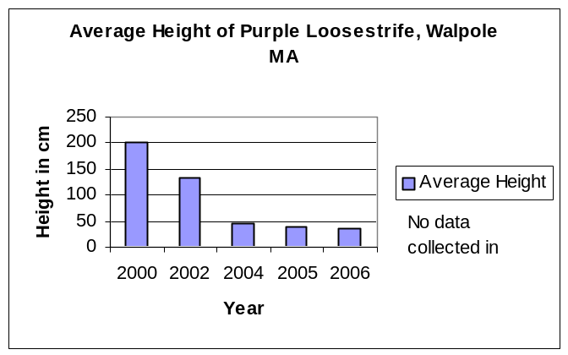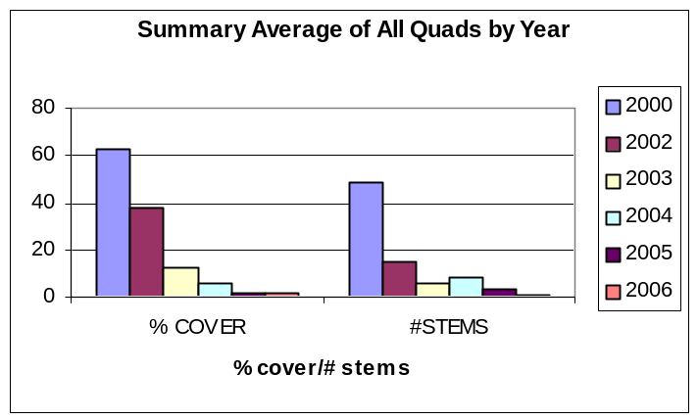Graph 1 Graph 2

Graph 3
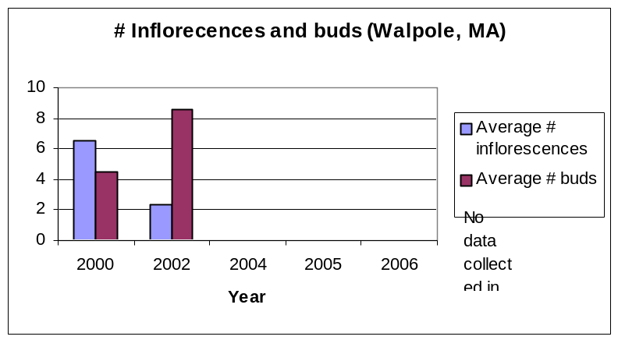
Sample Graphs from the Data.

Looking at your graphs, think about and answer the following questions in a paragraph.
- How quickly was the purple loosestrife altered? When was the most dramatic change?
- After how many years was purple loosestrife mostly eliminated?
- Do you think multiple year study/treatment is important? Explain your answer.
- How does reducing the number of buds and inflorescences help reduce purple loosestrife?
- Based on what happened in Walpole, would you recommend releasing beetles to control purple loosestrife in other locations? If yes, how many years would you recommend repeating the beetle release? Do you think the results are expected to be the same at other sites? Why or why not? What may lead to variability in site results?

Sample Graphs from the Data.

Graph 1 Graph 2

Graph 3
ANSWERS
Looking at your graphs, think about and answer the following questions in a paragraph.
- How quickly was the purple loosestrife altered? When was the most dramatic change?
Sample answer: Loosestrife reduced quickly at this site. It is hard to know what happened between 2000 and 2001 with no data, but there was a big drop both in # stems and % cover between 2002 and 2003.

- After how many years was purple loosestrife mostly eliminated?
By 2004 loosestrife was dramatically reduced.
- Do you think multiple year study/treatment is important? Explain your answer.
It was not completely reduced by 2002. It helped to have more beetles that year.
- How does reducing the number of buds and inflorescences help reduce purple loosestrife?
Buds are the part of the plant that produces seeds. This helps keep the plant from reproducing.
- Based on what happened in Walpole, would you recommend releasing beetles to control purple loosestrife in other locations? If yes, how many years would you recommend repeating the beetle release?
The Walpole data supports our hypothesis that Galerucella beetles reduce purple loosestrife. Based on this success, it seems like it would be effective at other sites. This worked with 3 releases, and it seems useful to do that many. (They may have other opinions.)
- Do you think the results are expected to be the same at other sites? Why or why not? What may lead to variability in site results?
We are getting varied results at other sites. As follow up you can use the next graphs with them for a classroom discussion. Site variability may have to do with how dense the stand is, how weather conditions affect the insects, how much flooding is on the site, how tall and dense the plants were to begin with. Your students may have good ideas not mentioned here.
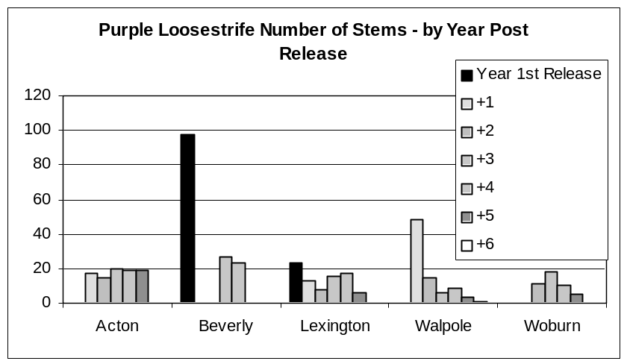
While most sites showed a reduction in number of stems, the Beverly site remained roughly the same. They were short to begin with.

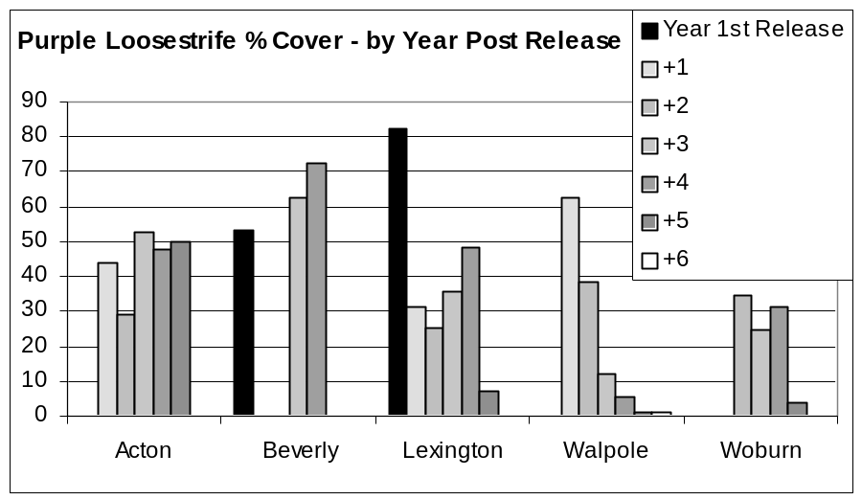

Sites in Walpole, Woburn and Lexington show a reduced in percent cover over time.

Further Classroom Discussion:

Purple loosestrife is an invasive plant that can take over a wetland, out-competing other plants, and preventing them from growing. This is a threat to biodiversity. Fewer species of plants are able to grow when purple loosestrife is present.

A second hypothesis is: Introducing Galerucella beetles will help increase biodiversity in a wetland.

Discuss:
- What additional data needs to be collected in order to test this hypothesis?
(Associated vegetation)

(Answer: What is the current biodiversity. We monitor associated vegetation to be able to answer this question. Surveying mammals, birds and amphibians will also help. )

- When do you think people should collect this data?
  - In a year before beetles have been released
  - In the year beetles have been released
  - Both before and after beetles have been released

(It would be useful to compare both before and after).

